NoSQL assignment 1 – David Hurley

1.

Conceptual

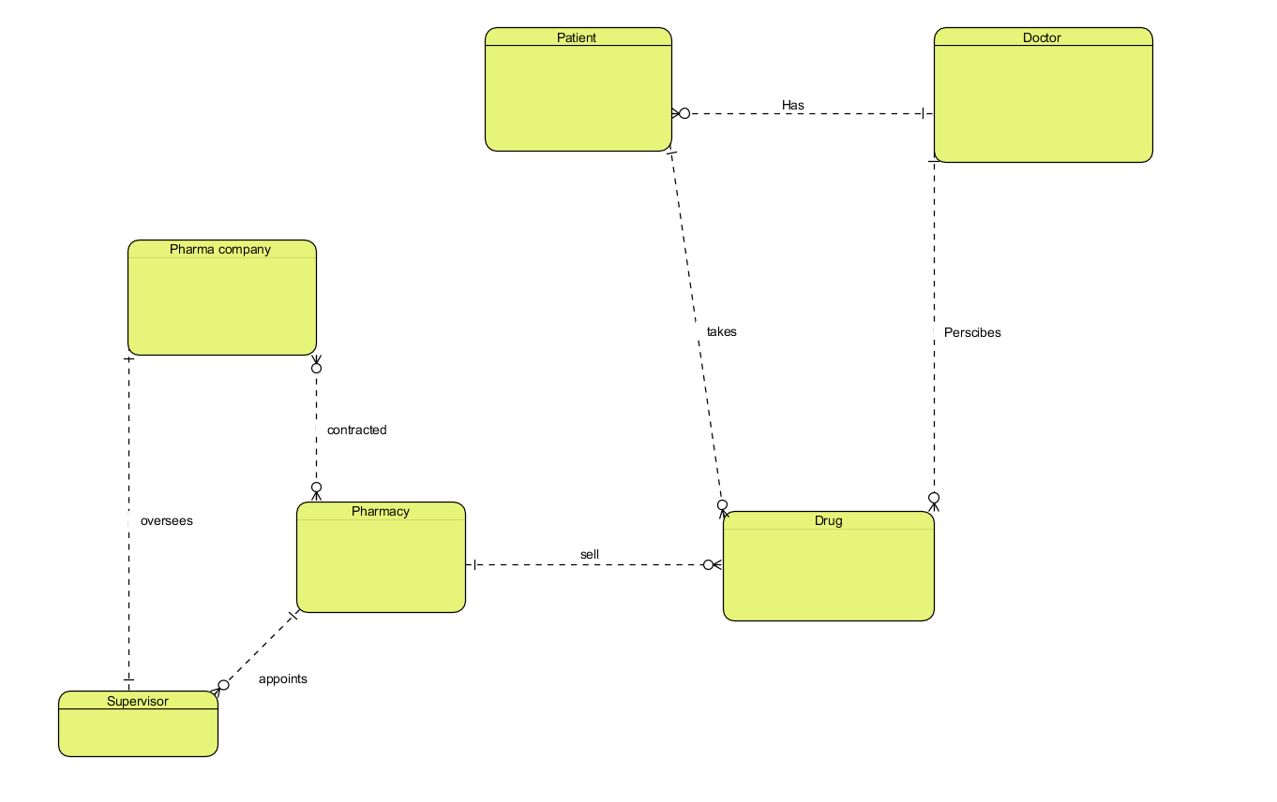

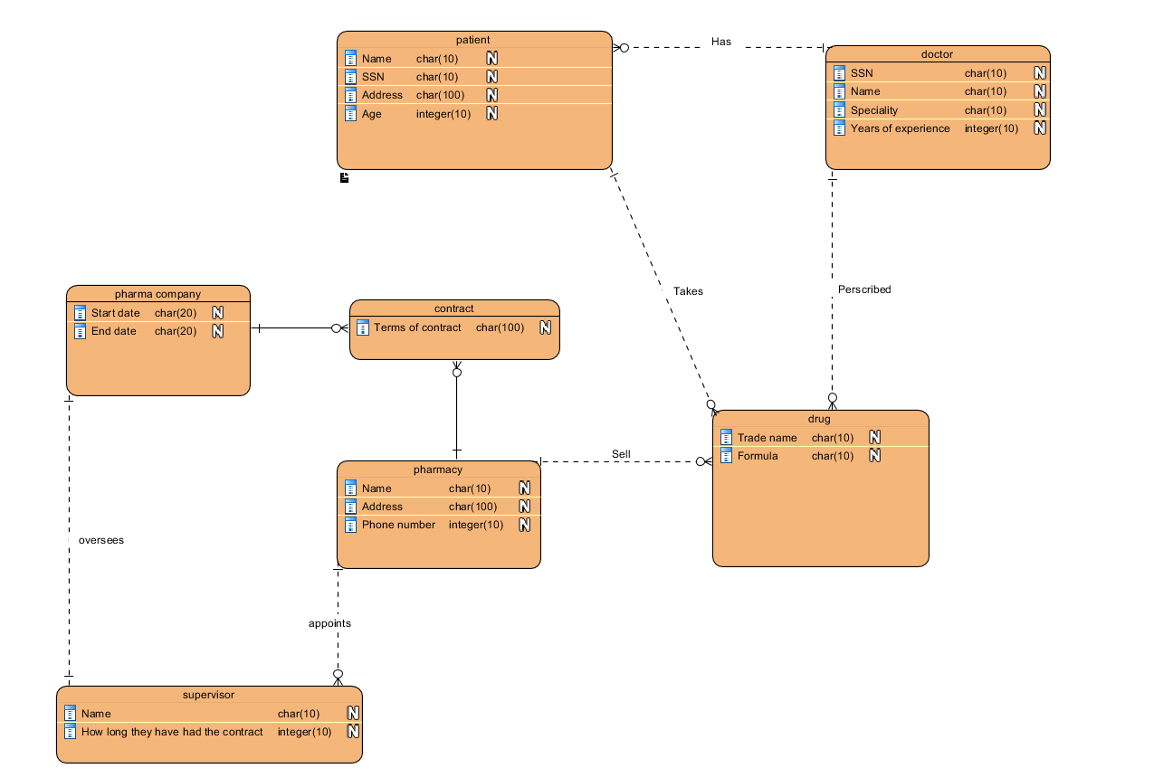

2.

Customer (**customerID**, lastName, firstName, address, city, state, zip, phone)

SalesPerson(**salespersonID**, salespersonFirstName, salespersonLastName, salespersonCode)

Sales_Order(**salesordernumber**, date, subtotal, tax, total, **customerID**, salespersonID)

Order_Line_Item(lineNumber, **salesordernumber**, quantity, unitprice, extendedPrice, **itemnumber**)

Item(**itemnumber**, unitprice, description)

Q3. 1.

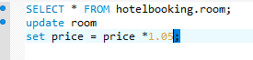

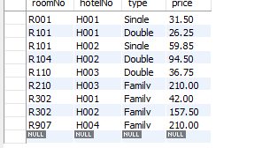

2.

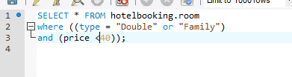

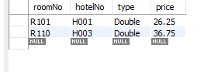

3.

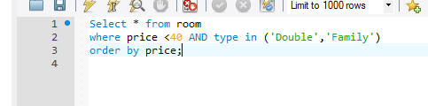

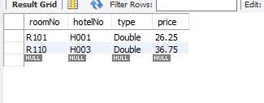

4.

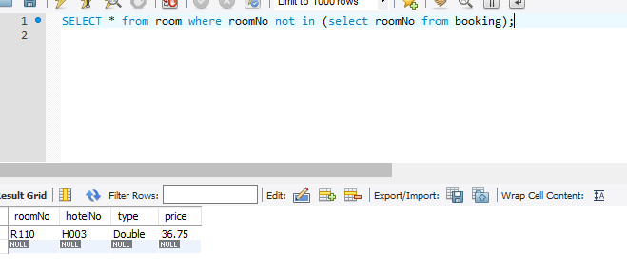

5.

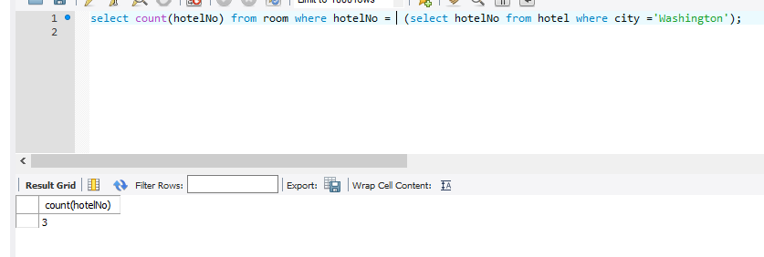

6.

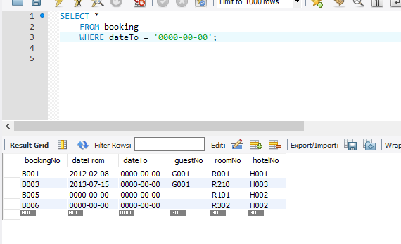

7.

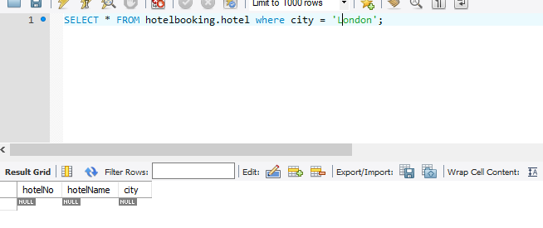

8.

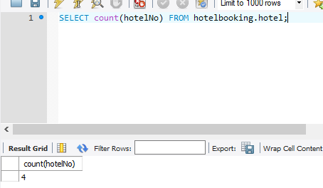

9. 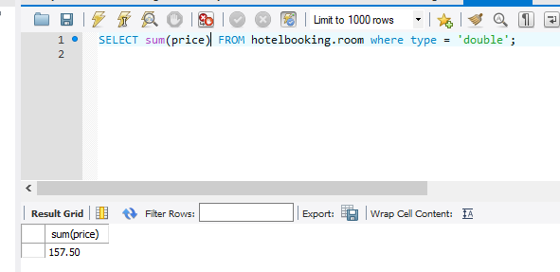

10. 

Q4:

